Q1. How to take input from the user in java programming?

Ans: if we want to take quick input from the user then we should go for Scanner class

Scanner class comes from java.util.package

If we are using Scanner class in our program then we should follow 3 steps

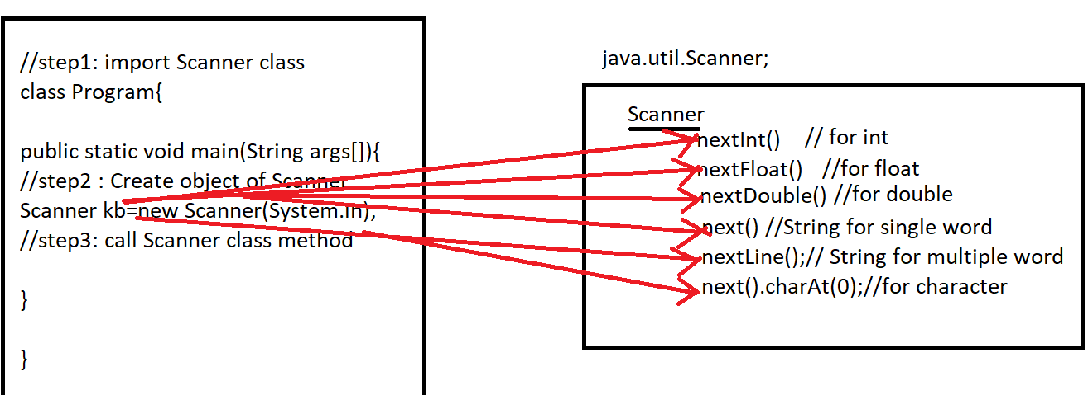

Step1: import Scanner class in the program(before class)

import java.util.\*;

OR

import java.util.Scanner;

Step2: Create an object of Scanner class(inside main)

Syntax:

ClassName objectName=new ClassName(Parameter).

Scanner input=new Scanner(System.in);

Step3: Call Scanner class method via object

int a=input.nextInt();//10

float b=input.nextFloat();//2.5

double c=input.nextDouble(); //45.6

String d=input.next(); welcome to bhopal

String e=input.nextLine();//welcome to bhopal

char f=input.next().charAt(0);//abc

Note: In java all per-defined methods written in camelCase.

In java all methods name should be start with verb

Q2. Write a java program to print sum of Two Numbers.

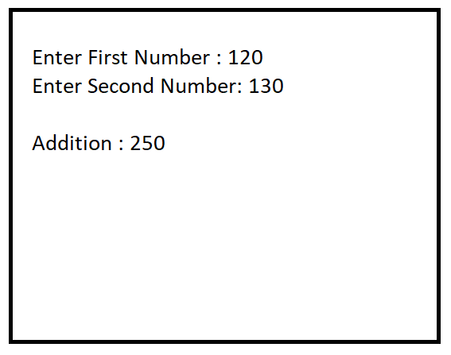

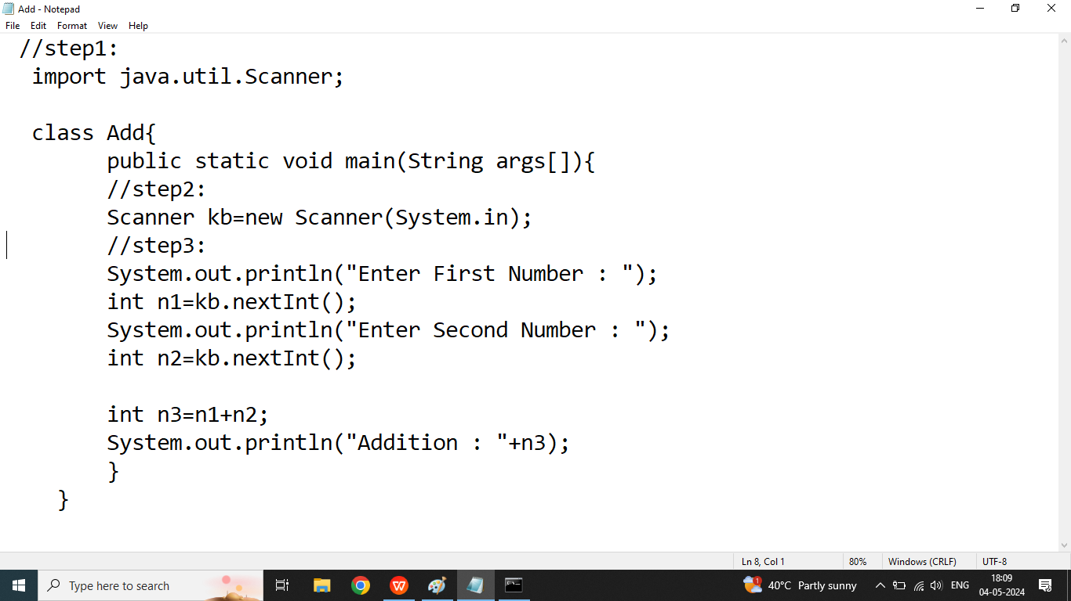

Q2. Write a java program to calculate area and parameter of Rectangle

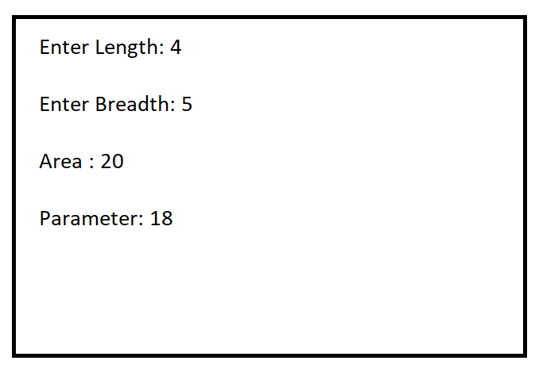

Q3. Write a java program to calculate Square and Cube of the Given Number

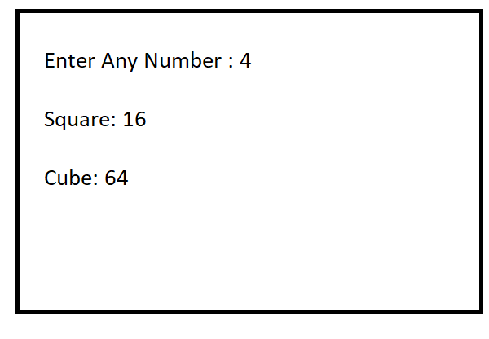

Q3. Write a java program to calculate area and circumference of Circle

